**Assignment 3**

create database sales

Create Database DB3

CREATE TABLE Employee (emp_id int ,emp_name varchar(20) ,mngr_id int,salary decimal(7,2),dept_id int )

INSERT INTO Employee VALUES

(7369, 'SMITH', 7902, 800.00, 10),

(7499, 'ALLEN', 7698, 1600.00, 30),

(7521, 'WARD', 7698, 1250.00, 30),

(7566, 'JONES', 7839, 2975.00, 20),

(7654, 'MARTIN', 7698, 1250.00, 30),

(7698, 'BLAKE', 7839, 2850.00, 30),

(7782, 'CLARK', 7839, 2450.00, 10),

(7788, 'SCOTT', 7566, 3000.00, 20),

(7839, 'KING', NULL, 5000.00, 10),

(7844, 'TURNER', 7698, 1500.00, 30),

(7876, 'ADAMS', 7788, 1100.00, 20),

(7900, 'JAMES', 7698, 950.00, 30),

(7902, 'FORD', 7566, 3000.00, 20),

(7934, 'MILLER', 7782, 1300.00, 10);

CREATE TABLE Department (dept_id INT PRIMARY KEY ,dept_name varchar(30));

INSERT INTO Department VALUES (10,'ACCOUNTING'),

(20,'RESEARCH'),

(30,'SALES'),

(40,'OPERATIONS');

Select * from Department

Select * from Employee

ALTER TABLE Employee ALTER COLUMN emp_id int NOT NULL;

ALter table Employee ADD Constraint PK_Employee_emp_id Primary Key (emp_id)

Alter Table Employee ADD CONSTRAINT FK_dept_id Foreign Key (dept_id) references Department(dept_id);

1. **write a SQL query to find Employees who have the biggest salary in their Department**

select e.emp_name,d.dept_name,d.dept_id,isnull(e.salary,0) from employee e right join Department d on e.dept_id = d.dept_id

where e.salary in (select max(salary)

from Employee e right join Department d

on e.dept_id = d.dept_id

group by e.dept_id) or e.salary is null

order by d.dept_id

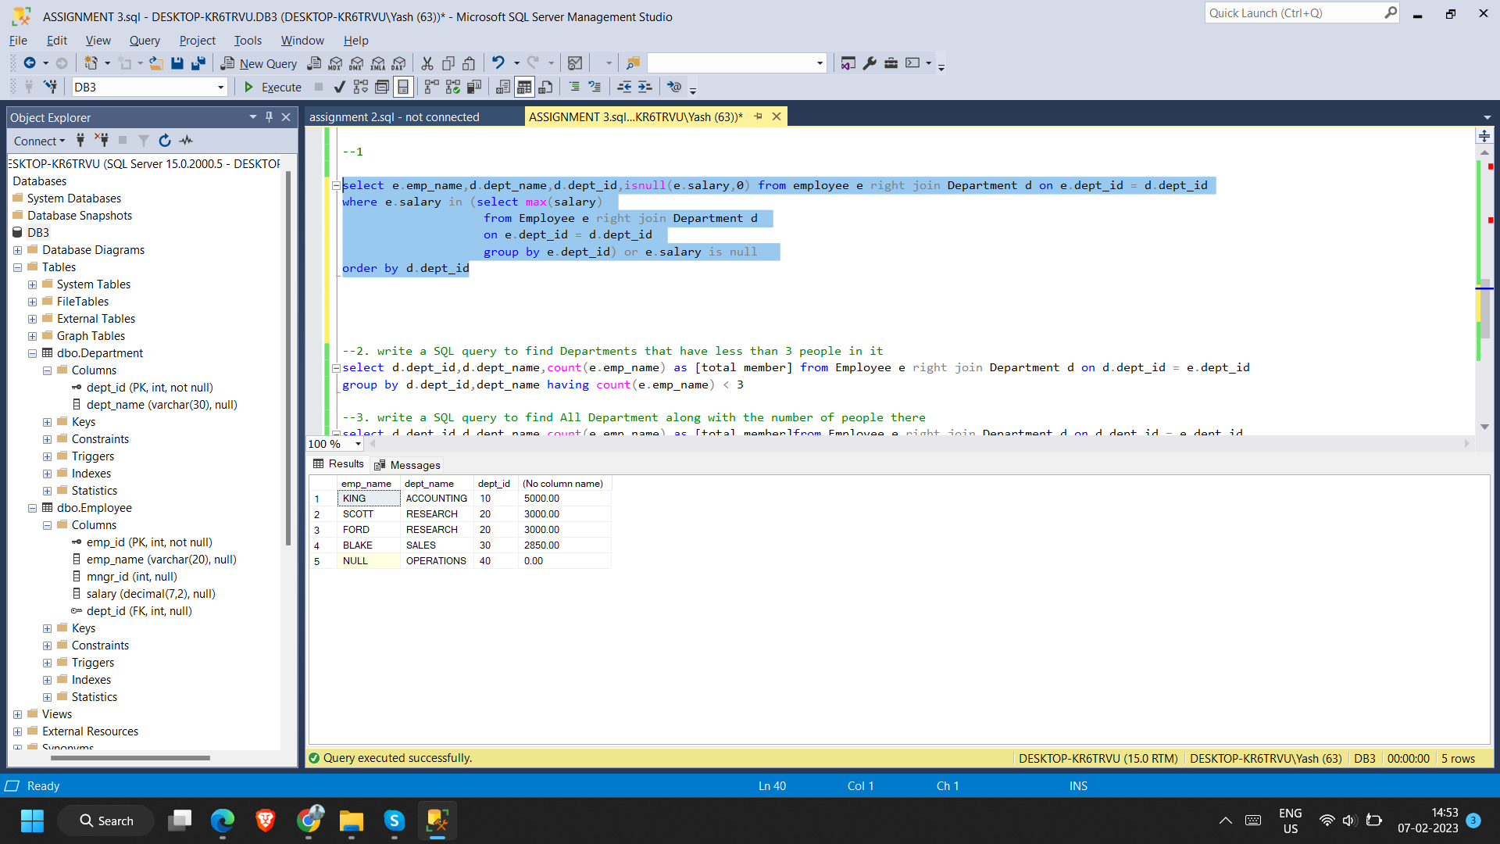

1. **write a SQL query to find Departments that have less than 3 people in it**

select d.dept_id,d.dept_name,count(e.emp_name) as [total member] from Employee e right join Department d on d.dept_id = e.dept_id

group by d.dept_id,dept_name having count(e.emp_name) < 3

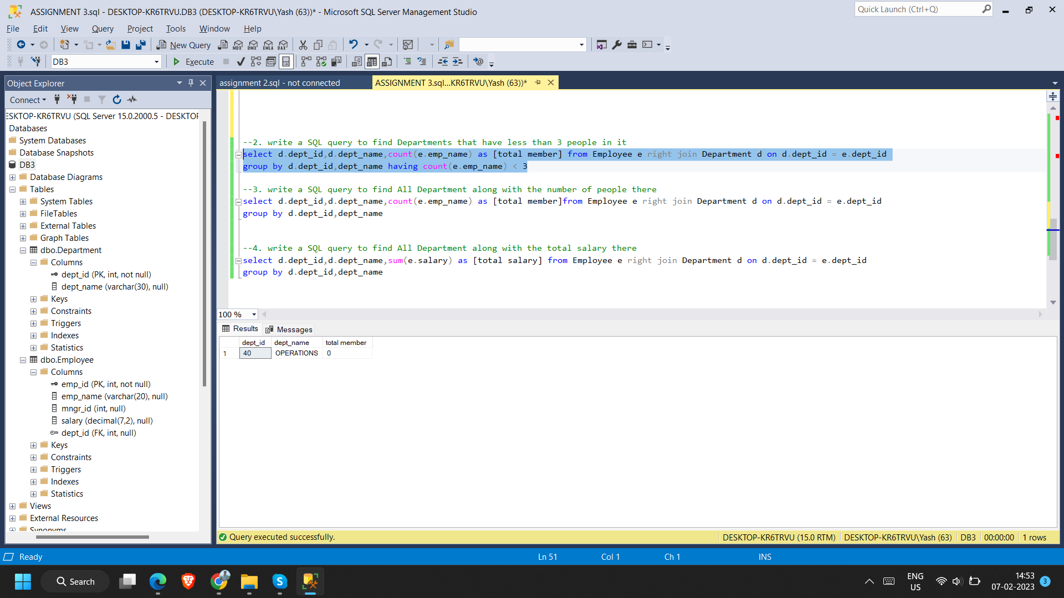

1. **write a SQL query to find All Department along with the number of people there**

select d.dept_id,d.dept_name,count(e.emp_name) as [total member]from Employee e right join Department d on d.dept_id = e.dept_id

group by d.dept_id,dept_name

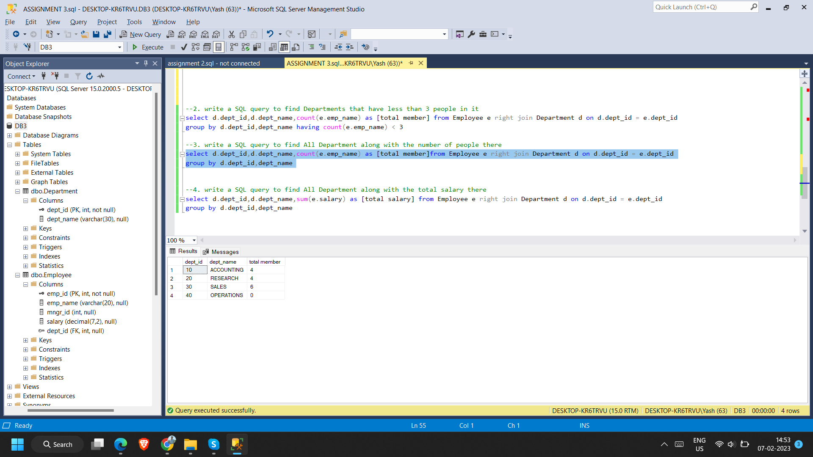

1. **write a SQL query to find All Department along with the total salary there**

select d.dept_id,d.dept_name,sum(e.salary) as [total salary] from Employee e right join Department d on d.dept_id = e.dept_id

group by d.dept_id,dept_name

